The first image I chose was by Gerry Winogrand. The three adjectives I used to describe this photo were energetic, risky, and creative. This photo is energetic because the subject is doing a flip high up in the air and is expressing a lot of energy. What he is doing is very risky, if he landed wrong he could be paralyzed for the rest of his life. This shot is creative because it’s not every day that a person takes a picture of someone doing a flip high in the air in the city.
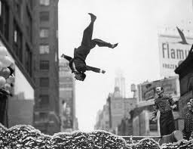
The second picture I chose was taken by Gregory Crewdson, and was taken in 2006. The three adjectives that I used to describe this photo were secluded, mysterious, and detailed. The reason I chose secluded to describe this photo is because the subject is the only person in the picture. He is out in the open, adventuring. This photo is also very mysterious looking. The little boy is walking by himself under a bridge surrounded by trees. The way that Gregory captured this photo it is extremely detailed. Everything in the picture is detailed, even the light.
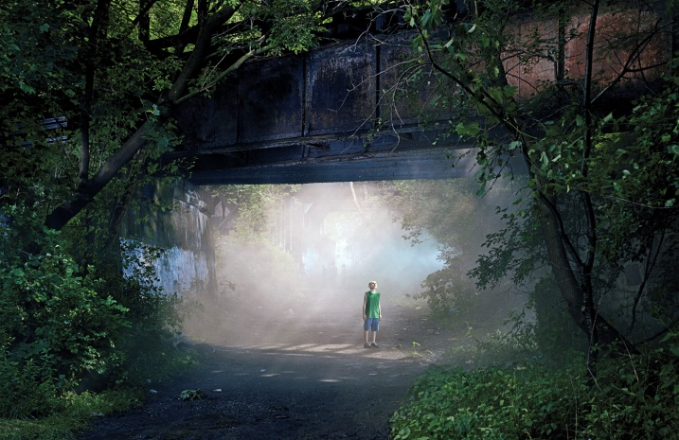

(The other picture is on the second page)

The third picture I found on the internet was taken by Sylvia Plachy, and was taken in 2005. The three adjectives that describe this picture are variety, contrast, and abnormal. I picked the word variety because there is variety in the people there and in the different objects and subjects around the station. This picture is black and white and shows a lot of contrast between the bright light coming in from the windows and the dark side of the room that isn’t lit up very much. The picture is also abnormal because of the amount of light coming in the windows and the airy effect of the picture.
